

Participatory Research Challenge Report
1500-2500 words – current word count including titles 2366

Project Title: Mapping Our Future

Project Team: Core Delivery Team
Peter Vujakovic (Geographer: CCCU co-lead and BCS)
Paula Owens (CCCU – Geography/Primary Education)
Giles Darkes (HTT – History/Cartography)
Partner organisations: Canterbury Christ Church University (CCCU), Historic Towns Trust (HTT), British Cartographic Society (BCS), Canterbury Archaeological Trust (CAT)
Advice and logistical aid were provided by other members of the partner organisations. Alex Kent (CCCU Project co-lead/BCS), John Hills (CCCU), Stephen Scoffham (CCCU), Jackie Eales (CCCU), Nick Millea (HTT), Keith Lilley (HTT), Jake Weekes (CAT).

Professional Discipline:

Geography, Cartography, Education (Primary Geography & History)

Background / Area Addressed:
The project evolved from a vision to co-create forms of education based on the acquisition and development of knowledge, skills, and critical thinking, and the creativity required to imagine and then build a more just and sustainable world. Heritage can be a keystone of community building and environmental understanding, gained by participatory learning and co-production of knowledge about localities. Children are introduced to the concepts of heritage in the primary curriculum, particularly in Key Stage 2, and deepen this understanding further in Key Stage 3.
The KS2 curricula in geography and history require creative investigation of local place and heritage. History pupils, for instance, must undertake a local study that, for example, explores how national history is reflected in their locality, with similar requirements for geography. Critical thinking and disciplinary skills are developed in both history and geography as pupils learn to analyse what different sources of evidence can tell them and how reliable they are. However, many primary teachers have little time to develop suitable resources and often report lack of their own skills, e.g., in map reading/use.
‘Teaching should equip pupils to ask perceptive questions, think critically, weigh evidence, sift arguments, and develop perspective and judgement.’
DfE (2013) History National Curriculum KS2
The project sought to address this need by developing links and relationships with teachers and schools in Kent (as a pilot) to build the network and capabilities required to work with the project team on ‘action research’ that would generate appropriate learning resources. The key was engagement activities encouraging participatory activity that would lead to co-produced research in the longer term.
‘Action research’ involves activity, evaluation, and critical reflection and changes in practice. Such co-produced research requires a development stage (this project), followed by implementation and further evaluation. The project engaged teachers in critical exploration of how maps (as one of the main resources for locality studies in the project) are complex cultural documents that aid understanding of place, heritage, and create opportunities to build a sustainable future.
CCCU and its partner organisations, working directly with schools developed the foundation for co-development of learning resources, piloted in Canterbury, with the intention that it will be adapted for nationwide use, underpinned by appropriate cartographic and education theory and best practice. The project was underpinned by Research England’s belief that:

“Participatory or co-produced research strengthens research outcomes by involving the communities and users of research, better recognising their experience, needs and preferences, and giving greater agency to communities to implement findings.”

While the project focused specifically on KS2, the project has the potential to be adapted to other Key Stages (especially KS3 because of the importance of transition from Primary to Secondary Education). The project also has relevance to adult community participation and learning about sustainability, sense of place, and heritage.

Definition of Participatory Research adopted:
This project adopts a participatory action research (PAR) approach. This research perspective focuses on action (in this case curriculum making and development of learning resources) through participation by those affected by the research theme. It involves collective investigation, experimentation and analysis based on professional or other relevant experience with the long term aim to rigorously test curriculum making through participatory action research..
This project applied two key levels of participation. The initial project brief and preparation involved a collaboration between academics, cartography professionals, and education specialists (see list of organisations and individuals above) and included input from the Chair of the HTT and past presidents of three national organisations (the BCS, Geographical Association (GA) and the Historical Association (HA); the latter two organisations represent Geography and History teachers in the UK).
The second participatory phase of the project involved testing learning resources and building an action research network through a full-day collaborative workshop with a range of teachers and educationists as co-creators of research for curriculum and learning resources. This was supported by prior presentation of specific curriculum development materials to teachers and education experts the GA and HA national conferences in 2022 and pre-testing with students recently transitioning from KS2 to KS3.

Aims & Objectives:
The project aimed to work with teachers and education specialist at KS2 and KS3 to understand how children use maps to understand their locality and provide the foundation for further development of learning resources that explore aspects of history, heritage, and geography. The objective of the project was to examine the style(s) of learning appropriate to delivery of the national curriculum in innovative and imaginative ways, focusing on KS2, an important nexus of learning in geography and history, drawing also on sustainability, heritage and cartography as key themes.
Map work formed the core of the project and was seen as providing a launch-pad for local fieldwork that is key to co-learning in History and Geography. Locality based participatory learning is regarded as key to developing children with a strong affinity to ‘place’ that is essential for a sustainable future.

Methods / Approach and Activity:

The project involved collaboration between the partner organisations to develop innovative learning resources to be tested with children and teachers. This included cartography at both landscape level (Ordnance Survey (OS) 1:50 000 scale) and city-scape level (Historical Towns Trust Historical Map of Canterbury 1:2 500 scale, including bespoke map layers created for the project). Other map types and scales were used, e.g., to set the regional context.

A key concept for understanding a settlement’s history and geography is a consideration of its ‘site and situation’; i.e., the intrinsic and extrinsic qualities of a site, as well a consideration of wider links: regional, national, and global.

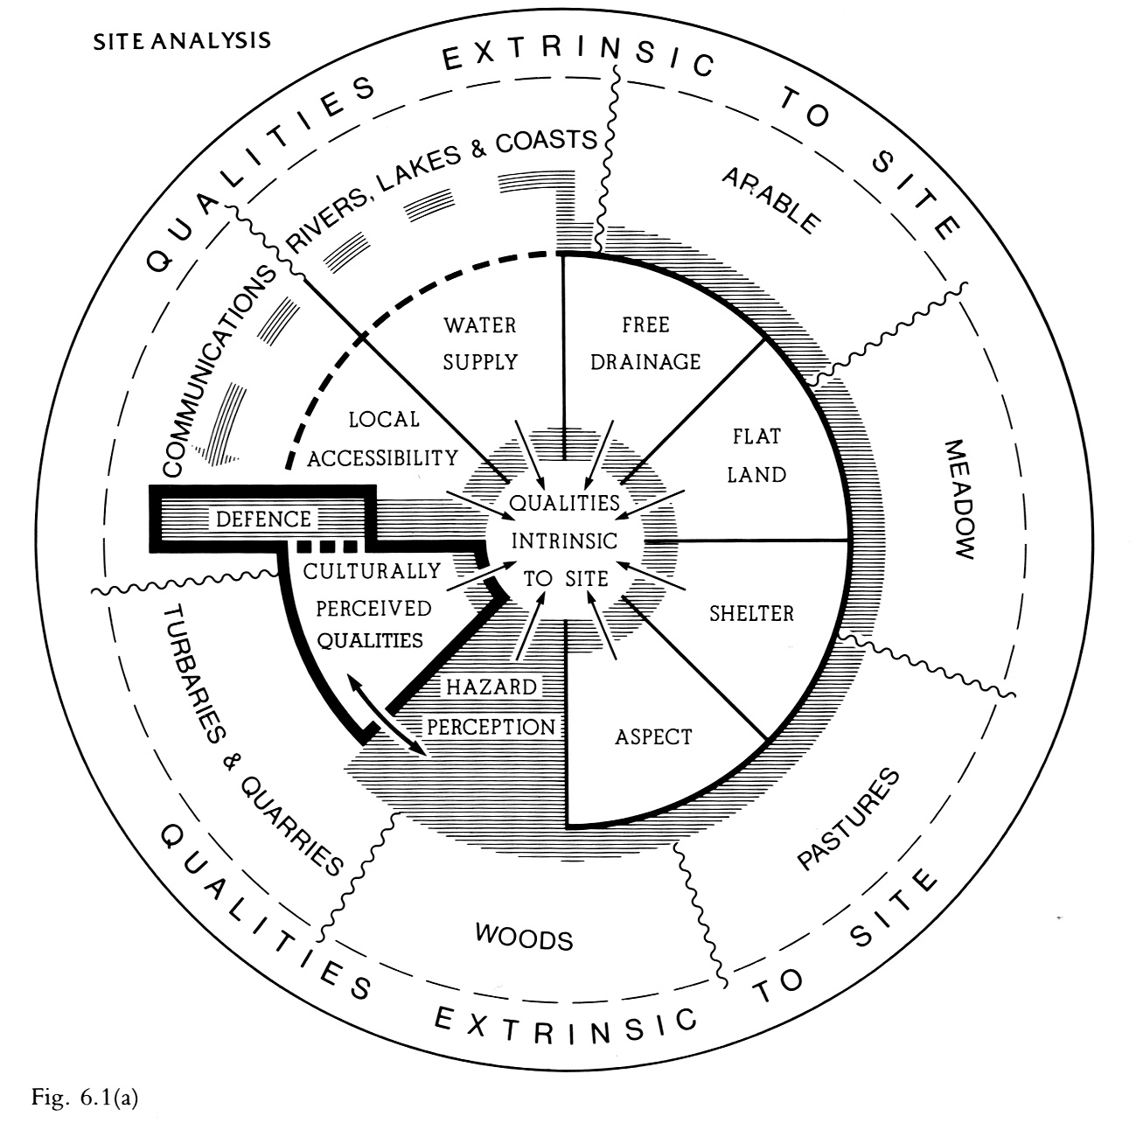
Roberts, B. (1987) The making of the English Village

Landscape level: understanding of maps at a range of scales, is critical to the Geography National Curriculum in England. Maps are a key tool for fieldwork in geography. and support historical enquiry. An interactive class exercise was developed that aimed at producing a meaningful interaction with OS maps through a focus on landscape heritage - Ancient Woodlands - that engenders meaning through discovery of the importance of these woodlands to heritage, ‘sense of place’ and sustainability (climate change, biodiversity, and health and wellbeing). Woodlands are an important extrinsic resource of a settlement such as Canterbury, in terms of the past (tangible resources), present (recreation and nature conservation), and future (climate change mitigation).

City scale: The Historic Towns Trust has a track-record of creating maps and atlases and has previously worked with CCCU and CAT to create the new historical map of Canterbury (publ. 2021). HTT mapping of many towns and cities in the last decade provides data to scale-up the project across the UK. The HTT data base provided the basis for detailed thematic digital maps used in the project. Intrinsic factors explored included location related to the River Great Stour (water supply and transport), regional communication and local accessibility, and defensibility (Roman to early modern periods).

Digimap was used to provide up-to-date context and to view historical maps and suggestions for its use in class made, for example searching for images of historical buildings on the GeoGraph, a schools function layer of Digimap.
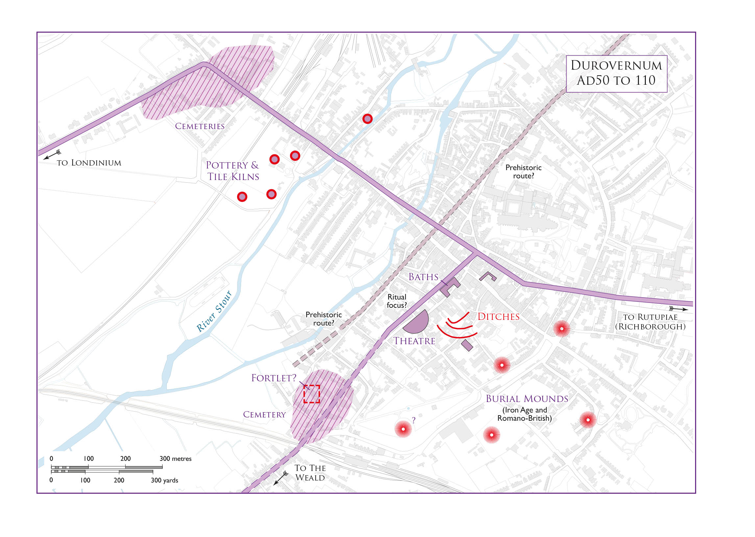
Romano-British Canterbury AD 50 to 110 (© Historic Towns Trust)

The approach and activities involved several phases:

- Development stage – evaluation the value of OS and HTT map as resources for leaning based on national curriculum guidance. The development of the learning resources was primarily by the core team of the partner organisations, with input from other experts as appropriate.

- Pre-testing concepts and provisional learning resources with education professionals (teachers and HE experts) via presentations to at the Geographical Association (GA) conference (April 2022) and the Historical Association (HA) conference (May 2022).

- Pre-testing learning resource based on OS map use with KS3 students, a recent transition group (Year 7) from KS2 (May 2022)

- Partnership action research workshop with teachers and education experts in Kent (July 2022)

Following the formal project period, participants will be issued (July-August 2022) with revised learning resources (trialled at the workshop) for class use and further refinement through collaborative action research.

While not a formal part of this project the intent is to provide FREE on-line materials to a wider set of teachers via the website of one of the partners and to seek further funding for evaluation of the pilot Kent based resources and roll-out of further resources across UK.

Results / Outcomes / Impact:

PRE-TEST 1 - The two key formats used (OS and HTT maps) were pre-tested through sessions at the GA and HA annual conferences.

OUTCOME Positive - the key issue was to establish that the resources were generally deemed appropriate by these professional groups for use at KS2 (and KS3). Feedback during the session was positive, with a consensus from teachers and education experts that the resources/learning activities where appropriate but that some limited adjustments, e.g., to the key terms used with students. The conferences were also used to network and recruit to the main action partnership workshop.

PRE-TEST 2 – The key OS map exercise was run with a co-ed group of students in Year 7 (first year Secondary, KS3). This provided an opportunity to test students who had been through KS 2 and should be able to work with maps effectively, as described by national level guidelines. This included (from guidance written using the students voice) the following abilities key to the map exercise:

I can use 4 and 6- figure coordinates to locate features.

I can use… maps to talk about contours and slope.

I can use maps to research factual information about locations and features.

I can relate maps to each other and to vertical aerial photographs.

Owens, P. (2016) Progression in Mapping Geography teaching resource – Primary, Edina

PARTNERSHIP ACTION RESEARCH WORKSHOP – The workshop was divided into several sections. These were intended to develop a critical working relationship for resource development and curriculum making. First, an ‘ice-breaker’ exercise using a resource familiar to teachers and part of the national curriculum for geography (the OS map exercise adjusted after pre-testing). Second, by introducing participants to the resources of the HTT (both the published maps and materials developed from digital resources, approach again modified following the HA session) and their application to field studies. And finally, through a session is designed to allow the participants to input into the ongoing development process by suggesting future directions and innovation in teaching and learning.

The participants consisted of six teachers with experience of delivering the KS2 and KS3 curricula (four from Primary sector and two from Secondary) and two lecturers in teacher education (Primary specialists).

ACTIVITIES:

Ice breaker – Map work 'Kent’s living landscape’

The ‘ice breaker’ exercise introduced a bespoke KS2/3 class exercise using a map series familiar to all, the OS 1:50 000 (the exercise that had been tested with KS3 (Year 7) and presented at the GA conference). The session provided the opportunity for participants to test and critique a novel exercise that used familiar map format. The aim was to introduce participants to each other, generate discussion concerning the general value of maps in geography and history teaching and finesse the exercise for use at KS2 and 3. The session was followed by oral and written feedback from participants (see below)

Canterbury HHT map – 'Making sense of place and heritage'
This session introduced participants to the Historic Towns Trust map series, specifically its new map of Canterbury. As well as the published map, specific bespoke layers of the map were used to investigate the geography and history of Canterbury and examine how teachers might use this resource in class and as a prelude to and resource for fieldwork. The session was followed by oral and written feedback from participants (see below)

‘Walking our place’ – field visit
The Canterbury Christ Church University main campus falls within the precincts of St Augustine’s Abbey, a key component of the Canterbury UNESCO World Heritage Site that also contains the Cathedral and the Saxon church of St Martin. A field visit was undertaken to ground the work of the previous session and discuss how visits to key sites can inform learning about place and sustainability, as well as making links to the wider world from a world-systems perspective. Field observation fed into discussion in the final section of the workshop,

'Creating novel learning resources' - future partnerships in curriculum creation
This final workshop session was designed to allow the participants to input into the development process by suggesting future directions and innovations in teaching and learning linked to historic, historical, and contemporary maps and related resources for the Geography and History curricula. This session included break-out groups and verbal and written feedback.

This final session was not designed to produce specific learning resources but to suggest directions for future partnership research by the partner organisations in collaboration with local schools/teachers (see outcomes below). The participants were invited to remain part of the on-going project.

Conclusions / Summary and Next Steps:

The project is deemed to be successful in several key areas:

- The first level partnership between the key organisational partners has been shown to be highly effective in delivering learning approaches/resources based on expertise in cartography underpinned by geography, history, and archaeological expertise. There is a determination to continue collaborative research and discussions relating to a possible collaboration have already commenced.

- The second level partnership with local teachers across KS2 and 3 produced important inputs from education professionals to the curriculum creation process and development of learning resources and laid the ground work for future participatory research. This was abetted by the participation of experts from Higher Education (Primary specialists) who understand the training/CPD needs of teachers, and the demands of the English National curriculum (adjustments will be made as the project seeks to scale-up to include other UK home nation’s curricula).

Feedback related to specific exercises and resources were provided by oral feedback and by three sets of written feedback. These included general feedback on applicability of learning resources (including specific comments designed to improve them), and general discussion of curriculum issues.

In total written 50 comments/recommendations were submitted: 17 regarding the ice-breaker exercise, 12 regarding the HTT map session, and 21 comments/recommendations of summative feedback regarding the day as a whole and future directions. The HE participants are preparing a separate summative report.

- The involvement of children who had recently moved from KS2 to KS3 provided insight into the nature of the transition regarding map skills attainment. Specifically, this element highlighted some of the issues related to the lack of group classwork and ‘hands-on’ map work during COVID pandemic.

- All stages of the project involved participatory action research that has led to improved understanding of education needs by the core team and to the improvement of innovative resources that will be provided to the participants for class use and feedback (and will result in provision of FREE on-line resources for local teachers – see below).

The next steps will involve development of the FREE on-line learning resources (to be hosted on the CCCU website with links from the other contributing organisations). The initial set of resources will be specific to Kent and Canterbury, but the aim is to extend the project to a wider area. HTT has produced historical maps for numerous towns and cities across the UK and these will form the basis for further bids for funding and development work. The action research element associated with this is significant, and it is envisaged that as the resources are ‘rolled-out’ to a wider user base, a more detailed examination and analysis of the value of the resources will be made and published in peer-review journals. The current work is already in the process of publication:

Darkes, G. (in press) How can maps help young people appreciate their locality? Maplines, Summer 2022, 18-19.

Owens, P. (in press) Know your Place! Using historical maps effectively with 7 – 11-year-olds, Maplines, Summer 2022, 20-21.

Finn, L. and Vujakovic, P. (in press) Woods on the map! Maplines, Summer 2022, 22-23.

A further article has been commissioned on the woodland mapping exercise by the Geographical Association for a Primary Geography special issue on ‘Natural Geographies’ (article submitted July 2022) This membership publication has the option to provide curriculum resource downloads via the GA membership website and the article will ask that teachers provide feedback directly to the project team if they use the materials in class.

Other articles are planned for submission to the Geographical Association and the Historical Association to ensure dissemination to the teaching profession and to further develop networks. It is envisaged that further action research will result in peer reviewed research publications as well as practical learning resources.

